Ian Altoveros

CS597

Broadcast Security Lab

In this lab, we were given a broadcast app that sends a message through ought the system.

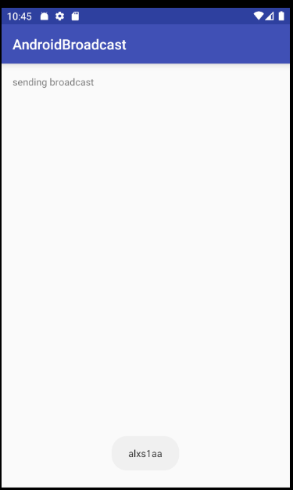

As we can see from the AndroidBroadcast app, it sends a message to the system which is called “alxs1aa” and the app is also a receiver, so it receives that message the app is sending. But there are risks when it comes to this app about sending messages in the system. There are malicious apps that could potentially intercept the message being sent. So here, I have a broadcast Attacker app

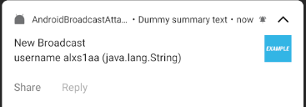 Here we can see that the broadcast was intercepted by the attacker app. This is because the broadcast being sent was not protected at all and being sent publicly. There are multiple ways to counteract this attack, one way is to use permissions which I did. Permissions in the android allow or deny apps on certain actions, in this case I am denying the hacker app to intercept the message. I did this by adding permissions in the android manifest like so.



I also allowed the receiver the permission to receive the message

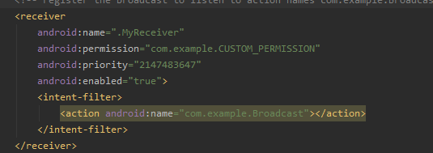

Then I sent the broadcast with the custom permission



This way the broadcast is only sent and received by an app with the “com.example.CUSTOM_PERMISSION” line. If we run the code once more,

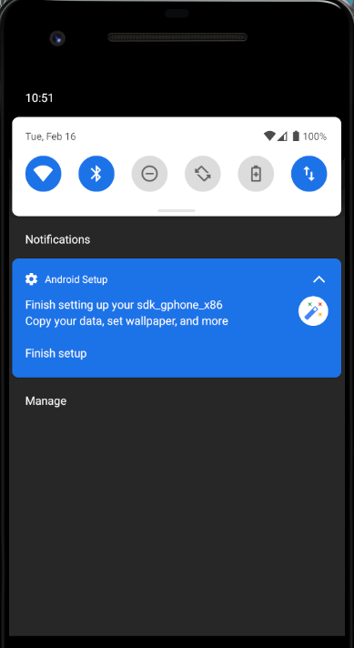

It is not able to intercept the message anymore.